**LEED start up and shut down procedures**

1. **Make sure AES (Auger) is clear.** Move Sample manipulator to 1280. Then move LEED holder to X=3.0 inches (inside to inside) or X = 4.78125 inches (outside to outside). The outside to outside is labeled in green, and the inside to inside measurements is labeled in red in the figure below.

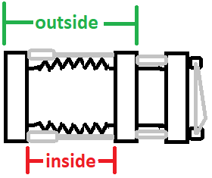

1. Set Anode offset to 475 V.
2. Warm up filament
   1. Two options to do this:
      1. Option 1:
         1. Turn filament current to 1 Amp for 10 mins
         2. Slowly turn up to 2.5 Amps for operation (emission current is about 20 microamps)
      2. Option 2:
         1. Slowly turn up filament by small half turn (inner 0-5) increments every 1-2 minutes.

**Key note**: is that pressure does not go near 5E-9. *If so this could damage the filament in the LEED while LEED is probably outgassing.*

1. Set Wehnelt = 0.
2. Turn Suppression all the way up (about 4.5)
3. Turn off the RGA filament and the Ion gauge.

**DO NOT TURN ON THE SCREEN HV UNTIL ALL LIGHTS ARE OFF!**

1. Set energy to desired level (ex: 50 eV)
2. Turn off room lights and make sure that no light is going near/into LEED.
3. Turn on Screen HV switch and set to 6.00 on the knob (this is the outer 6)
4. Adjust L3 (prop) and L2 (offset) to get a good pattern.

* L2 offset requires a bit of course L2 before measurements shown on LEED display for L2 offset

**Remember: Turn off the screen HV before turning the lights on.**

1. Pull LEED out to X=6.0 inches (inside to inside) or X = 7.78125 inches (outside to outside).

-This allows you to move the sample holder if you want to do something else after LEED.